**Data Flow Diagram & User Stories**

|  |  |
| --- | --- |
| Date | 31 January 2025 |
| Team ID | LTVIP2025TMID59149 |
| Project Name | A Collage Food Choices Case Study |
| Maximum Marks | 4 Marks |

**Data Flow Diagrams:**

A Data Flow Diagram (DFD) is a traditional visual representation of the information flows within a system. A neat and clear DFD can depict the right amount of the system requirement graphically. It shows how data enters and leaves the system, what changes the information, and where data is stored.

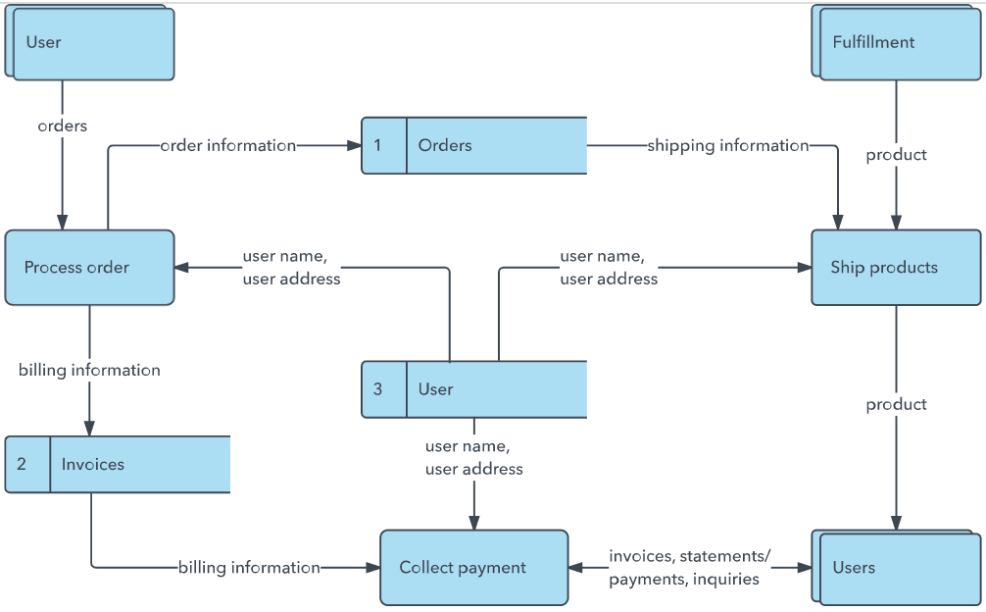

**User Stories**

|  |  |  |  |  |  |  |
| --- | --- | --- | --- | --- | --- | --- |
| **User Type** | **Functional Requirement (Epic)** | **User Story Number** | **User Story / Task** | **Acceptance criteria** | **Priority** | **Release** |
| Customer (Mobile user) | Registration | USN-1 | **As a** student on a tight budget, **I want to** filter food choices based on price range,**so that** I can eat within my daily budget without compromising on nutrition | I can set my dietary preferences | High | Sprint-1 |
|  |  | USN-2 | **As a** user craving fast food,  **I want to** quickly find nearby fast food options with healthy alternatives,**so that** I can satisfy my craving without making unhealthy decisions. | **As a** user craving fast food, **I want to** quickly find nearby fast food options with healthy alternatives,  **so that** I can satisfy my craving without making unhealthy decisions. | High | Sprint-1 |
|  |  | USN-3 | **As a** busy professional, **I want to** plan my meals for the week in advance,**so that** I can save time and maintain a consistent diet. | I can get recommendations based on time of day or my previous choices. | Low | Sprint-2 |
|  |  | USN-4 | **As a** person who likes to cook at home,**I want to** get recipe suggestions based on available ingredients,**so that** I can avoid food waste and save time planning meals. | I can view ingredient lists and health scores for each dish. | Medium | Sprint-1 |
|  | Login | USN-5 | **As a** busy professional,  **I want to** plan my meals for the week in advance,  **so that** I can save time and maintain a consistent diet. | I can prepare calorie chart. | High | Sprint-1 |
|  | Dashboard |  |  |  |  |  |
| Customer (Web user) |  |  |  |  |  |  |
| Customer Care Executive |  |  |  |  |  |  |
| Administrator |  |  |  |  |  |  |
|  |  |  |  |  |  |  |
|  |  |  |  |  |  |  |
|  |  |  |  |  |  |  |